EXSI Details.

ExSI commands are classified in to different categories based on their functionality, the following are the categories
- General Scanner Control
- Exam Control
- Task Control for batch scanning
- Scanner hardware control
- Image data flow control
- Error Handling
- Real time commands
  - General Scanner Control

ConnectToScanner
The External Scanner Interface shall provide the ability to connect a client to the scanner, provided that the client machine is pre-authenticated by the scanner. The External Scanner Interface shall retain the authenticated clients across scanner software reloads

Command Name | ConnectToScanner
Params | product=string
Returns | ConnectToScanner=ok|fail
Precondition | Can execute immediately  Can execute without exam  Can execute during TPS reset
Synced | Yes
SVAT Command | None
Description | This command will be used by client to connect to a specific scanner
How it works | Scanner side maintains configuration file that has list of authorized products. Using this command client sends its product name. EXSI server verifies if this product is authorized to connect. If yes it returns ok otherwise it returns fail.

GetScannerState
The External Scanner Interface shall provide the ability to retrieve the current scanner status at any given instant
Command Name | GetScannerState
Params | None
Returns | GetScannerState=ok|fail scanner=idle|prescanning|refscanning|refprepped|prepped|scanning
Precondition | None
Synced | Yes
SVAT Command | None
Description | To get the scanner current state
How it works | Exsi Server saves the scanner state every time there is a scanner event received from SCAN. GetScanner state command returns this state value to client.  Sequence diagram is shown below

SetScannerMode
The External Scanner Interface shall provide the ability to change the scanner mode from “clinical” to “research”. However, in order for this command to succeed the research option key should be present, and the scanner should be configured to provide mode change access.

Command Name | SetScannerMode
Params | Research
Returns | SetScannerMode=ok|fail
Precondition | canExecuteTpsNotReady=false  canExecuteWithoutExam=false  canExecuteIfPrepped=false  canExecuteDuringScanning=false
Synced | Yes
SVAT Command | PRESC_MODE
Description | This command is used to change the scanner mode from clinical to research  This command will be used by the user during an exam to move to research mode.
How it works | This command looks for the parameter passed. Depending on the parameter passed it calls PRESC_MODE SVAT command with value mapped below as a parameter.  Research =1

LockUI
The External Scanner Interface shall provide the ability to prevent users from interacting with the scan desktop on MR operator’s console UI

Command Name | LockUI
Params | On | Off
Returns | LockUI=ok
Precondition | canExecuteTpsNotReady=false
Synced | Yes
SVAT Command | LOCK_UI, UNLOCK_UI
Description | This command provides the capability to put glass pane on the MR host PC UI when a remote operation is in progress to ensure that no UI interaction is allowed. It is possible to view UI & observe all operations. It is also possible to unlock either by using another command with “off” option or by clicking on “unlock UI” button available on console. If system crashes then complete system shuts down closing all of the UI. If external system crashes then user needs to unlock from console.
How it works | This command is wrapper to the LOCK_UI & UNLOCK_UI commands in SVAT. If the option is “On”, LOCK_UI command is sent. For “Off” option, UNLOCK_UI command is sent. Default return value from SVAT will be sent directly to client.

  - Exam Control

LoadProtocol
The External Scanner Interface shall provide the ability to load any protocols, already installed in the scanner, to the task list. The ability to load the entire protocol, or selected tasks from that protocol shall be given as an option
Command Name | LoadProtocol
Params | ge|site|service [dir=dir_name] path=protocol_name/task#,task#|task#-task#
Returns | LoadProtocol=ok|fail taskKeys=string,string,…  Returns error if protocol name doesn’t exist at the given location ( ge or site or service / or in the directory mentioned)
Precondition | canExecuteTpsNotReady
Synced | Yes
SVAT Command | PROTOCOL_DIR, PROTOCOL_MODE, LOADPROTOCOL
Description | This command is used to load a specific protocol from ge/site/service/directory.
How it works | Logical diagram below

EndExam
The External Scanner Interface shall provide the ability to end the current exam
Command Name | EndExam
Params | None
Returns | EndExam=ok|fail
Precondition | canExecuteDuringScanning=false
Synced | Yes
SVAT Command | END_EXAM
Description | This command is used to End currently running exam
How it works | This command is a wrapper to the existing SVAT END_EXAM command. Return value from SVAT will be passed to the client. If command is not successful command would return failure.

GetExamInfo
The External Scanner Interface shall provide the ability to retrieve details of the current exam. The details shall include, but not limited to the following items:
Exam number, Patient Name, ID, Date of Birth, Sex, Weight, Operator Name, Exam Description
Command Name | GetExamInfo
Params | None
Returns | GetExamInfo=ok|fail  with patient/exam info encoded as DICOM tag=value pairs, e.g. 0010,0010=string 0010,0020=string  Study id, Patient name, Patient ID, Patient DOB, Sex, Age, Weight, Operator name, Radiologist, Ref physician, description, Additional patient history  Eg. GetExamInfo=ok 0020,0010=40 0010,0010=patient^Name 0010,0020=1234 0010,0030=20010923 0010,0040=M 0010,1010=013Y 0010,1030=44.000 0008,1070=operator 0008,1060=radiologist 0008,0090=dr
Precondition | canExecuteDuringScanning=false
Synced | Yes
SVAT Command | None
Description | This command is used to get current exam information.
How it works | Logical diagram is shown below.

DisablePrompts
The External Scanner Interface shall provide the ability to set exam level options for the duration of current exam. These options shall include the following:
a. Disabling all advisory errors and pop-ups (Disabling the modal pop-ups, which require user acknowledgement from the MR operator console shall allow the continuous flow of remote operations)
Command Name | DisablePrompts
Params | none | advisory
Returns | DisablePrompts=ok|fail
Precondition | default
Synced | Yes
SVAT Command | SCN_POPUPS
Description | This command is used to Disable prompts for All/Grx/Advisory/auto_start.
How it works | Suppressed pop-ups are Grx SWIFT popup, auto start and advisory. None of them are related to hazard. Grx SWIFT popup & auto start pop are warning pop-up. There is no impact if they are suppressed. Suppressing advisory pop-up would set the advisory values automatically.  Logical diagram is shown below

GetTaskList
The External Scanner Interface shall provide the ability to retrieve the list of tasks currently available in the Task List, preserving the order in which they are listed, along with a unique key for each task.
Command Name | GetTaskList
Params | none
Returns | GetTaskList=ok|fail taskKeys=string,string,…
Precondition | canExecuteTpsNotReady=false, canExecuteDuringScanning=false,  canExecuteIfPrepped=false
Synced | Yes
SVAT Command | None
Description | This command is used to Get all task displayed in the task list.
How it works | Logical diagram is shown below

SelectTask
The External Scanner Interface shall provide the ability to select a task by providing the unique key of that task
Command Name | SelectTask
Params | taskKey=string
Returns | SelectTask=ok|fail  Returns following errors:  -no task key given by user  -incorrect task key
Precondition | Default
Synced | Yes
SVAT Command | None
Description | This command is used to select the specific task entered as task key.
How it works | Logical diagram is shown below

ActivateTask
The External Scanner Interface shall provide the ability to select a task by providing the unique key of that task
Command Name | ActivateTask
Params | taskKey=string
Returns | ActivateTask=ok|fail  returns failures:  -If task cannot be selected for given task key.  -the current task state does not permit activate operations if task is in scanned state, View edit fails, save fails, download fails
Precondition | Cannot execute when prepped, TPS not ready, during scanning
Synced | No
SVAT Command | VIEW_EDIT, ACCEPT_RX, SCANOPS_EVENT
Description | This command moves a task to the ACT state depending on its current state.
How it works | This command is a meta command executes the above mentioned 3 SVAT command depending on its current state.  If task is in NEW state = > VIEW_EDIT->ACCEPT_RX->SCANOPS_EVENT  If task is in INRX state => ACCEPT_RX->SCANOPS_EVENT  If task is in RXD state => SCANOPS_EVENT  If task is in ACT state => Failure message

  - Task Control for batch scanning

setRxParams
The External Scanner Interface shall provide the ability to set or modify prescription parameters, including the slice collection for the given task key
The External Scanner Interface shall provide the ability to set a coil using task key
Command Name | setRxParams
Params | [taskKey=string] [coil=string] [TR=float] [TE=float] [TI=float] [ETL=int] [NUMECHO=int] [NEX=float] [FLIP=int] [BW=float] [XRES=int] [YRES=int]
Returns | SetRxParams=ok|fail
Precondition | Cannot execute if TPS is not ready
Synced | Yes
SVAT Command | VIEW_EDIT to setUp the task.
Description | Sets the general prescription parameters as described above.  (a) If a task Key is provided, the task is selected in the task list and view edited if allowed to be modified.  (b) If no task key is provided, the selected task is view edited if allowed.  The desired parameters are set if the view edit is successful.  The params value setting continues for other params even if one/more of the requested params setting fails.
How it works | Diagram is shown below

setRxGeometry
The External Scanner Interface shall provide the ability to set or modify prescription parameters, including the slice collection for the given task key
Command Name | setRxGeometry
Params | [taskKey=string] [coil=string] [plane=axial/sagittal/coronal/oblique] [startloc=int|r,a,s] [endloc=int|r,a,s] [slices=int] [spacing=int] [thick=int] [fov=int] [freqdir=swap/unswap/AP/RL/SI]  where startloc and endloc should be in r,a,s only for oblique scan plane
Returns | SetRxGeometry=ok|fail
Precondition | Cannot execute if TPS is not ready
Synced | Yes
SVAT Command | Plane: SCAN_PLANE Coil: SET_COIL Startloc: START_LOCS, Endloc: END_LOCS  Slices: NO_2D_SLICES Spacing: SLICE_SPACING Thick: SLICE_THICKNESS  Fov: FOV Freqdir: FREQ_DIR
Description | Sets the parameters related to geometry like plane, coil, start location, end location, slices, spacing, thickness, fov and freqdir.  (a) If a task Key is provided, the task is selected in the task list and view edited if allowed to be modified.  (b) If no task key is provided, the selected task is view edited if allowed.  The desired parameters are set if the view edit is successful..
How it works | ExSI server maps the input params to the legacy SVAT commands.  The param value setting continues for other params even if one/more of the requested params setting fails.  Here is the order in which parameters are set  1. SCAN_PLANE 2. SET_COIL 3. START_LOCS 4. END_LOCS 5. NO_2D_SLICES 6. SLICE_SPACING 7. SLICE_THICKNESS 8. FOV 9. FREQ_DIR

setRxGeometry3p
The External Scanner Interface shall provide the ability to set or modify prescription parameters, including the slice collection for the given task key
Command Name | setRxGeometry3p
Params | [taskKey=string] [coil=string] [centerloc=r,a,s] [spacing=r,a,s] [thick=int] [fov=int] [freqdir=swap/unswap]
Returns | SetRxGeometry3p=ok|fail
Precondition | Cannot execute if TPS is not ready
Synced | Yes
SVAT Command | Coil: SET_COIL Centerloc: SET_SL_CENTER Spacing: SET_SL_SPACING  Thick: SLICE_THICKNESS Freqdir: FREQ_DIR  Plane: SCAN_PLANE (always send 3-plane)
Description | Sets the parameters related to geometry for 3 plane like plane(always send 3-plane), coil, center location, spacing, thickness, fov and freqdir.  (a) If a task Key is provided, the task is selected in the task list and view edited if allowed to be modified.  (b) If no task key is provided, the selected task is view edited if allowed.  The desired parameters are set if the view edit is successful.
How it works | ExSI server maps the input params to the legacy SVAT commands.  The param value setting continues for other params even if one/more of the requested params setting fails.

prescan
The External Scanner Interface shall provide the ability to perform
- auto prescan b. manual prescan c. skip prescan d. set prescan values while showing/hiding prescan UI
Command Name | prescan
Params | auto|manual=start/done | skip | values=hide/show [r1=int] [r2=int] [tg=int] [cf=int] [x=int] [y=int] [z=int]
Returns | Prescan=ok|fail
Precondition | Cannot execute if TPS is not ready,  Cannot execute if scanner is in prepped state  Cannot execute during acquisition scanning and ref scanning, but can execute during prescanning.
Synced | Auto Prescan : Synced  Manual Prescan start/stop :Synced  Skip Prescan, setting of prescan/shim value : Not Synced
SVAT Command | auto :APS_EVENT  manual value=start/stop :START_LOOP_EVENT, STOP_LOOP_EVENT  skip :PSC_MPS_EXIT_MPS  values=hide [r1=] [r2=] [tg=int] [cf=int] [x=int] [y=int] [z=int] :PSC_UPDATE_VAL, SC_SET_SHIM, PSC_MPS_EXITMPS  values=show [r1=] [r2=] [tg=int] [cf=int] [x=int] [y=int] [z=int] :START_LOOP_EVENT, PSC_UPDATE_VAL,  PSC_SET_SHIM, STOP_LOOP_EVENT
Description | Prescan can be performed using any of the below mentioned options.  1) Manual Prescan without any prescan value modification:  Prescan manual=start/done  2) Auto Prescan:  Prescan auto  3) Skip Prescan:  Prescan skip  4) Set prescan values while showing the manual prescan UI as done from user interface:  Prescan values=show [r1=int] …  5) Set prescan values without showing manual prescan UI:  Prescan values=hide [r1=int] …
How it works | Details in the figure below

GetPrescanValues
The External Scanner Interface shall provide the ability retrieve prescan values of the current task after performing a Prescan operation
Command Name | GetPrescanValues
Params | None
Returns | GetPrescanValues=ok|fail stat=[ok|fail|prescanning] r1=int r2=int tg=int cf=int
Precondition | Cannot execute if TPS is not ready
Synced | Yes
SVAT Command | PSC_QUERY_STATUS
Description | Returns the status of prescan e.g. prescanning, last prescan was successful or not.  Returns the prescan values (r1, r2, tg, cf)of the last prescan if it was successful.
How it works | Please refer the diagram for more details

ReferenceScan
The External Scanner Interface shall provide the ability to perform “reference scan” for operations required prior to beginning acquisition
Command Name | ReferenceScan
Params | None
Returns | ReferenceScan=ok|fail
Precondition | Cannot execute if TPS is not ready,  Cannot execute if scanner is in prepped state  Cannot execute if scanning is in progress
Synced | No
SVAT Command | REF_EVENT
Description | Performs reference scan.  Performs download/full(or smart) prescan if the task has not been already downloaded/prescanned.  Ref-scans the selected task in the task list UI.
How it works | ExSI server maps the command to the legacy SVAT command for reference scan.

Prep
The External Scanner Interface shall provide the ability to perform “scan prep” for operations required prior to beginning acquisition.
Command Name | Prep
Params | None
Returns | Prep=ok|fail
Precondition | Cannot execute if TPS is not ready,  Cannot execute if scanner is in prepped state  Cannot execute if scanning is in progress
Synced | No
SVAT Command | PREP_SCANNER
Description | Performs prep.  Performs download/full(or smart) prescan if the task has not been already downloaded/prescanned.  Preps the selected task in the task list UI.
How it works | ExSI server maps the command to the legacy SVAT command for prep.

Scan
The External Scanner Interface shall provide the ability to start scanning any prescribed and saved task of the current exam by providing the unique task Key associated with that task.
The External Scanner Interface shall provide the ability to rescan an already scanned task of the current exam. The requested task should be the currently active task
Command Name | Scan
Params | None
Returns | Scan=ok|fail
Precondition | Cannot execute if TPS is not ready,  Cannot execute if scanning is in progress
Synced | No
SVAT Command | SCAN_EVENT
Description | Performs scan.  Performs download/full(or smart) prescan/prep if the task has not been already downloaded/prescanned/prepped.  Rescans an already scanned selected task.  If the scanned task is active, rescans and generates images in the same task.  If the scanned task is not active, duplicates the task, scans and generates images in the new task.
How it works | ExSI server maps the command to the legacy SVAT command for scan.

StopScan
The External Scanner Interface shall provide the ability to immediately stop scanning (including pre-scanning) of the current task. This command shall be equivalent to the Stop Scan Button on the hardware panel (hard keys). This command shall have no effect if a scanning task is unavailable at the time of receiving the command.
Command Name | StopScan
Params | None
Returns | StopScan=ok|fail
Precondition | Cannot execute if TPS is not ready,  Cannot execute if scanning is in progress
Synced | No
SVAT Command | STOP_SCAN
Description | Stops all kinds of scanning like prescanning, ref scanning, scanning.
How it works | ExSI server maps the command to the legacy SVAT command for stop scan.

setCvs
The External Scanner Interface shall provide the ability to modify control variables (CV) for the currently downloaded task. All CVs shall be allowed to be modified in research mode. Only pre-defined CVs for pre-defined psds shall be allowed to be modified in clinical mode
Command Name | setCvs
Params | name1=string value name2=string value …
Returns | setCvs=ok|fail taskkey = string name1=string value name2=string...
Precondition | Cannot execute if scanner is in prepped state.  Cannot execute if scanning is in progress.  Cannot execute if TPS not ready
Synced | Yes
SVAT Command | None
Description | All CVs shall be allowed to be modified in research mode. Only pre-defined CVs for pre-defined psds shall be allowed to be modified in clinical mode.
How it works | A CV access controller class shall contain the list of CVs and PSDs allowed to be modified. The data in the class could be embedded in the code or obtained from an external file. The CV setting continues for other CVs even if one/more of the requested CV setting fails.

getCvs
The External Scanner Interface shall provide the ability to retrieve control variable (CV) values for a currently downloaded task
Command Name | getCvs
Params | name1 name2 …
Returns | getcvs=ok|fail name1=string value... name2=string value
Precondition | Cannot execute if TPS not ready
Synced | Yes
SVAT Command | None
Description | Provides the CV values for the currently active task.
How it works | Sends a geocomm request to ScannerService and receives the CV values in the response.

  - Scanner hardware control.

GetConnectedCoils
The External Scanner Interface shall provide the ability to retrieve a list of all connected coils.
Command Name | GetConnectedCoils
Params | None
Returns | GetConnectedCoils=ok|fail coils=string[,string,...]
Precondition | Can execute without Exam  Cannot execute when TPS not ready
Synced | Yes
SVAT Command | CONNECTED_COILS
Description | This command returns all connected coils.
How it works | This command sends SVAT command CONNECTED_COILS to get list of all connected coils.

PatientTable
The External Scanner Interface shall provide the ability to advance the cradle in order to position the scan location at isocenter
The External Scanner Interface shall provide the ability to set landmark
The External Scanner Interface shall provide the ability to turn on/off any cradle movements.
Command Name | PatientTable
Params | advanceToScan autoLandmark=on/off emulation=on/off freeze=on/off landmark=int
Returns | PatientTable=ok|fail
Precondition | Can execute without Exam  Cannot execute when TPS not ready  Cannot execute during scanning
Synced | No
SVAT Command | IPG_ADVANCE_TOSCAN, LANDMARK, AUTOLANDMARK, IPG_TABLE_EMULATION  FREEZE_TABLE
Description | This command provides ability to turn on/off any cradle movements, automatically move cradle to desired position
How it works | This command sends SVAT command IPG_ADVANCE_TOSCAN to move the cradle to desired position. LANDMARK to set the landmark. FREEZE_TABLE to turn on/off the table movement.

  - Image data flow control.

GenerateImageTypes
The External Scanner Interface shall provide the ability to enable/disable generating the Magnitude, Phase, Imaginary & Real image types in any combination.
Command Name | GenerateImageTypes
Params | all | [magnitude] [phase] [real] [imaginary]
Returns | GenerateImageTypes=ok|fail
Precondition | Cannot execute if scanner is in prepped state.  Cannot execute if scanning is in progress.  Cannot execute if TPS not read
Synced | Yes
SVAT Command | None
Description | Generates all or few of different image types that is magnitude, phase, real and imaginary in any combination.  The command works on currently active task.
How it works | Sets the CV rhrcctrl “bitMask to indicate types of images to be generated” .  Here are the bit values to be set:  Magnitude: 0x1  Phase: 0x2  Real: 0x4  Imaginary: 0x8  Please refer setCv command to find details of CV setting mechanism.

installImageTypes
The External Scanner Interface shall provide the ability to enable/disable saving non-realtime images to the database
Command Name | installImageTypes
Params | all | none | [magnitude] [phase] [real] [imaginary]
Returns | InstallImageTypes=ok|fail
Precondition | Cannot execute if scanner is in prepped state.  Cannot execute if scanning is in progress.  Cannot execute if TPS not ready
Synced | Yes
SVAT Command | None
Description | Installs all or few of different image types (that is magnitude, phase, real and imaginary in any combination) if the type is being generated. It works on active task. Therefore the command should be issued post download. Settings are applicable on the images generated from next scan. Rescan of the same task would retain these settings.
How it works | Creates bit mask from the input params indicating the following:  Magnitude: 0x1, Phase: 0x2, Real: 0x4, Imaginary: 0x8  The bitmask is sent from EXSI server to ScannerService. In scn process a packet containing exam number, series number, scan number and bit mask is created and sent to TIR to block image installation as requested.
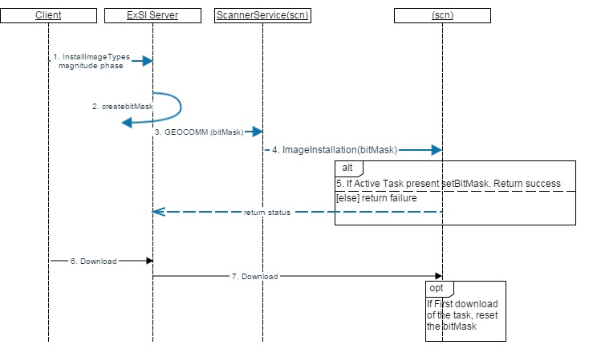

GenerateIntermediateImages
The External Scanner Interface shall provide the ability to enable/disable generating images from each channel of the prescribed coil configuration. This feature will be effective only for multi-channel coils. If enabled, an image from each enabled “image type” shall be provided from each channel. In addition, an image for each enabled “image type” shall be provided from all channels combined.
Command Name | GenerateIntermediateImages
Params | on|off
Returns | GenerateIntermediateImages=ok|fail
Precondition | Cannot execute if scanner is in prepped state.  Cannot execute if scanning is in progress.  Cannot execute if TPS not ready
Synced | Yes
SVAT Command | None
Description | Generates images from all channels of the selected coil along with combined images. The command works on currently active task
How it works | sets CV "saveinter“ to value 1(0) as per the user input of on(off)  Please refer setCv command to find details of CV setting mechanism.
  - Error Handling

NotifyEvent
The External Scanner Interface shall provide the ability to register and deregister for scanner state changes. When registered, the client shall be notified when a scanner state change occurs.
Upon a successful acquisition, the External Scanner Interface shall send the “Acquisition Complete” event to the client, which has registered for this event.
When batch image receive components submit the first image(of a task) to the database, the External Scanner Interface shall send the “First Image Available” event to the client along with total number of images expected, which has registered for this event
When batch image receive components submit the last image (of a task) to the database,, the External Scanner Interface shall send the “All Images Available” event to the client, which has registered for this event
The External Scanner Interface shall return an error response to synchronous commands which did not execute successfully. The error response shall contain pre-defined error codes and optional translated character string (in the system default character set) which can optionally be presented to the operator by the external client.
The External Scanner Interface shall broadcast error messages when known exceptions and error conditions occur within the scanner. A mechanism shall be provided for the clients to register and get notified on these error conditions.

Command Name | NotifyEvent
Params | NotifyEvent [all=on|off] | [acquisition=on|off] [error=on|off] [exam=on|off] [rxError=on|off] [recon=on|off] [scanmode=on|off] [scanner=on|off] [tps=on|off] [firstImage=on|off]
Returns | notifyEvent = ok|fail  [all=on|off] | [acquisition=on|off] [error=on|off] [exam=on|off] [rxError=on|off] [recon=on|off] [scanmode=on|off] [scanner=on|off] [tps=on|off] [firstImage=on|off]
Precondition | Can be executed without exam  Can be executed immediate  Can be executed during TPS Reset
Synced | Yes
SVAT Command | None
Description | Notifies the client for the registered events.  The client can register for all or some of these events:  Scanner state change (idle/prescanning/prepped/refprepped/scanning/refscanning)  Scanner mode (clinical/research) change  TPS state (resetting/reset_failed)  Exam state (started/ended)  Acquisition done  First Image available(submitted to database) with total # of expected images  All images available(last image submitted to database, i.e. recon done) with actual # images processed and sent to database.  RxError to indicate the errors that are shown on the UI during prescription like parameter not filled etc.  Error to indicate predefined errors for which client has registered using ermes or some other mechanism. For e.g. error to indicate that an invalid CV set has been attempted etc. The details to be included in the Error Handling requirements/design.images. The command works on currently active task
How it works | Please refer to images below.

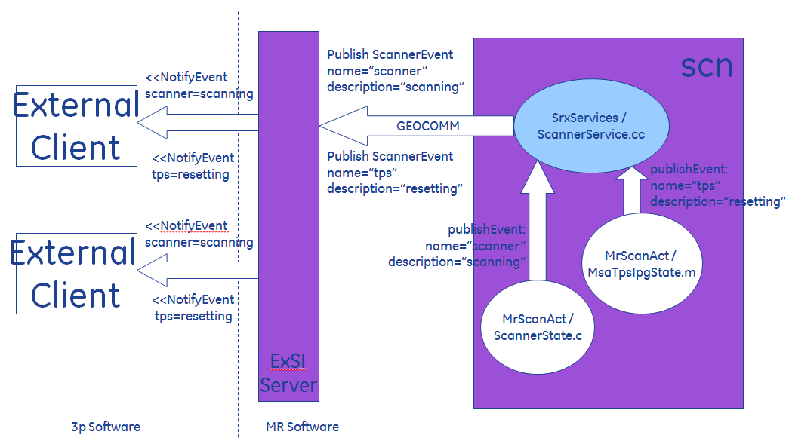

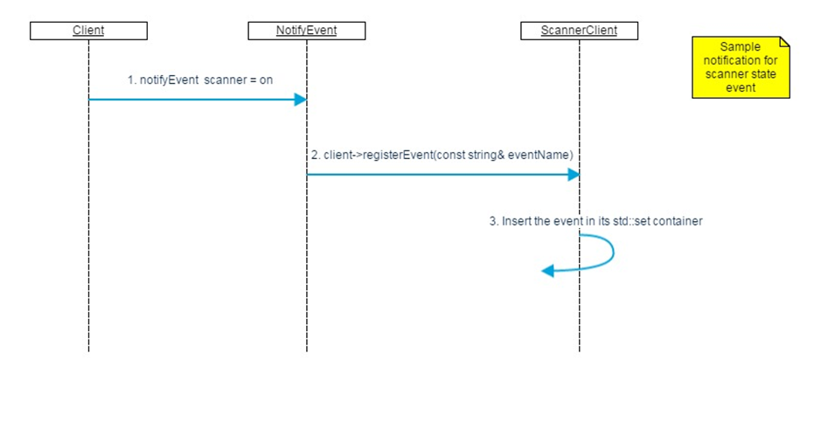

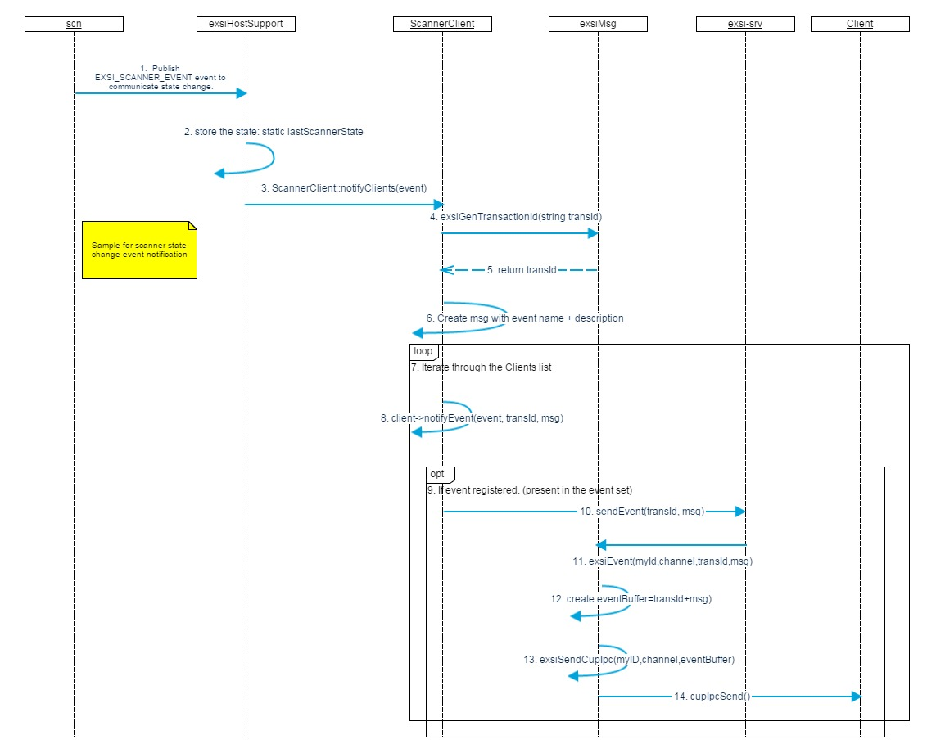

  - Real time commands

SetRealtimeOptions
The External Scanner Interface shall provide the ability to start realtime scanning with or without displaying real-time acquisition screen.
Command Name | SetRealtimeOptions
Params | EXSI_CONTROLLER = EXSI_HOST |EXSI_REMOTE
Returns | SetRealtimeOptions=ok |fail
Synced | Yes
Workflow | This command will be used by the user before starting real time scan.  EXSI_CONTROLLER = EXSI_HOST This will enable user interface when real time scanning starts  EXSI_CONTROLLER = EXSI_REMOTE This will hide user interface when real time scanning starts
Description | This command will enable the system to start real time scanning with or without real time user interface.
How it works | EXSI sends GEOCOM request to SCN, which would check if system is idle and there is active task available. If not it returns error. If yes then it sets the flag. This flag is used to hide/show RTIA UI when scan is requested.



PauseScan
The External Scanner Interface shall provide the ability to pause the current real time acquisition after completing the current pass.
Command Name | PauseScan
Params | none
Returns | PauseScan=ok|fail
Precondition | Cannot execute if TPS is not ready,  Cannot execute without exam  Can execute if real time scanning is in progress
Synced | Yes
SVAT command | PAUSE_EVENT
Description | If realtime scanning is in progress it pauses the scan.  If scanner is not scanning it returns fail with error “"scanner is not scanning“  If scanner is already paused, it returns fail with error "scanner is already paused"  If scanner is not realtime, it returns fail with error "series is not realtime series"
How it works | It uses SVAT command PAUSE_EVENT

ResumeScan
The External Scanner Interface shall provide the ability to resume a paused realtime acquisition.
Command Name | ResumeScan
Params | none
Returns | ResumeScan=ok|fail
Precondition | Cannot execute if TPS is not ready,  Cannot execute without exam  Can execute if real time scanning is in progress
Synced | Yes
SVAT command | RESUME_EVENT
Description | If realtime scanning is in paused state it resumes the scan.  If scanning is not paused, it returns fail with message “scanner is not paused”  If task is not real time, it return fail with message “series is not realtime series”
How it works | It uses svat command RESUME_EVENT

GenerateIntermediateImages
The External Scanner Interface shall provide the ability to generate real-time images for all channels of coil
Command Name | GenerateIntermediateImages
Params | on | off
Returns | GenerateIntermediateImages=ok|fail
Precondition | Cannot execute if scanner is in prepped state.  Cannot execute if scanning is in progress.  Cannot execute if TPS not ready
Synced | Yes
SVAT command | None
Description | This command controls generation of images from all channels of coil during real time scan.
How it works | It sets saveinter CV to generate images from all channels

GenerateImageTypes
The External Scanner Interface shall provide the ability to enable/disable generating the Magnitude, Phase, Imaginary & Real image types in any combination.
Command Name | GenerateImageTypes
Params | all | [magnitude] [phase] [real] [imaginary]
Returns | GenerateImageTypes=ok|fail
Precondition | Cannot execute if scanner is in prepped state.  Cannot execute if scanning is in progress.  Cannot execute if TPS not ready
Synced | Yes
SVAT command | None
Description | Generates all or few of different image types that is magnitude, phase, real and imaginary in any combination.  The command works on currently active task.
How it works | See the setting of rhrctctrl below.

installImageTypes
The External Scanner Interface shall provide the ability to enable/disable saving realtime images to the database.
Command Name | installImageTypes
Params | all | none | [magnitude] [phase] [real] [imaginary]
Returns | InstallImageTypes=ok|fail
Precondition | Cannot execute if scanner is in prepped state.  Cannot execute if scanning is in progress.  Cannot execute if TPS not ready
Synced | Yes
SVAT command | None
Description | Installs all or few of different image types (that is magnitude, phase, real and imaginary in any combination) if the type is being generated. It works on active task. Therefore the command should be issued post download. Settings are applicable on the images generated from next scan. Rescan of the same task would retain these settings.
How it works | Creates bit mask from the input params indicating the following:  Magnitude: 0x1, Phase: 0x2, Real: 0x4, Imaginary: 0x8  The bitmask is sent from EXSI server to ScannerService. In scn process a packet containing exam number, series number, scan number and bit mask is created and sent to RIR to block image installation as requested.

RealTimeImages
The External Scanner Interface shall provide the ability to enable/disable sending realtime images to the Auto-view window. Images sent to auto-view shall be shown immediately unless the auto-view is configured to be on the review mode
Command Name | RealTimeImages
Params | [autoview=on|off]
Returns | RealTimeImages=ok|fail
Precondition | Cannot execute if scanner is in prepped state.  Cannot execute if TPS not ready
Synced | Yes
SVAT command | None
Description | This command controls real time image display in autoview.  autoview=on This will display real time images in autoview  autoview=off This will stop displaying images in autoview
How it works | See the setting of rhrctctrl below.

BeginRealtimeUpdate
The External Scanner Interface shall provide commands to begin and end real time parameter changes. The External Scanner Interface shall queue all parameter updates from a “BeginRealtimeUpdate” command until an “EndRealtimeUpdate” command is received. Table
A “Begin Realtime Update” shall discard any prior uncommited changes. “End RealtimeUpdate” command shall provide the option to commit or discard accumulated realtime parameter updates.
Command Name | BeginRealtimeUpdate
Params | none
Returns | BeginRealtimeUpdate=ok|fail
Synced | Yes
SVAT command | None
Description | The External Scanner Interface shall queue all parameter updates from a  “BeginRealtimeUpdate” command until an “EndRealtimeUpdate” command is received.
How it works | This command will create new object for including all real time requests. It will also reset the counter used to track number of requests.

EndRealtimeUpdate
The External Scanner Interface shall provide commands to begin and end real time parameter changes. The External Scanner Interface shall queue all parameter updates from a “BeginRealtimeUpdate” command until an “EndRealtimeUpdate” command is received. Table
A “Begin Realtime Update” shall discard any prior uncommited changes. “End RealtimeUpdate” command shall provide the option to commit or discard accumulated realtime parameter updates.
Command Name | EndRealtimeUpdate
Params | commit | discard
Returns | EndRealtimeUpdate=ok|fail
Synced | Yes
Workflow | This command will be used after sending all realtime requests.  Commit: This argument will send all parameter updates to real time application for processing.  Discard: This argument will not send any parameter update. It cleans up all requests in the queue.
Description | The External Scanner Interface shall queue all parameter updates from a  “Begin Realtime Update” command until an “End Realtime Update” command is received.
How it works | If commit is passed then it sends all parameter requests in the queue to RTPSI for processing. It returns the result after processing.  If discard is passed it deletes the object that holds all requests in the queue. Resets the request counter.

SetRealtimeParams
SWRS.EXSI.214: The External Scanner Interface shall provide the ability to send the following list of real time parameters to an active realtime series.
1. FOV
2. Slice thickness
3. Frequency Direction (along row/column)
4. Flip Angle
5. Track mode
6. Trip related parameters
7. Discarded Data Acquisition
8. Parameters for auto test framework
These parameters shall be queued in the active series until a separate command is sent to commit
the changes.
Command Name | SetRealtimeParams
Params | [centerloc=r,a,s rowvec=r,a,s columnvec=r,a,s] [flip=int] [fov=int] [freqdir=" EXSI_ROW "|" EXSI_COLUMN "] [thick=int] [track=" EXSI_ON"] [trip_nex=int] [dda=int] [trig=" EXSI_ON "|" EXSI_OFF "] [tripRef=" EXSI_ON"] [trip_fov1=float] [trip_fov2=float] [trip_fov3=float] [trip_rlocsi=float] [trip_rlocap=float] [trip_rlocrl=float] [rotate=int transpose=int path=string]
Returns | SetRealtimeParams=ok |fail
Synced | Yes
Workflow | This command will be used for sending all real time requests.  [centerloc=r,a,s rowvec=r,a,s columnvec=r,a,s]  All the three arguments must be provided together. First one is center of location to be acquired. Second and third argument will give row and column vector respectively.  [fov=int] This is to set the fov  [thick=int] This is to set the thickness  [freqdir=" EXSI_ROW "|" EXSI_COLUMN "] This is to set the frequency direction  [track=on] set to 1 to request a tracking  [dda=int] to control the first phase imaging dda after switching back from tracking  [trip_nex=int] nex value in trip  [trig=on/off] to switch external trigger on/off during realtime imaging  [trip_fov1=float] the first pass FOV of the tracking PSD  [trip_fov2=float] the second pass FOV of the tracking PSD  [trip_fov1=float] the third/fourth pass FOV of the tracking PSD  [trip_rlocap] the AP center of the tracking PSD  [trip_rlocsi] the SI center of the tracking PSD  [trip_rlocrl] the RL center of the tracking PSD  [tripRef=on] set to 1 to request a reference scan in realtime EPI  [rotate=int transpose=int path=string] rotate angle. Transpose and golden data path for geometry testing
Description | This command shall add real time parameter request into queue.
How it works | If commit is passed then it sends all parameter requests in the queue to RTPSI for processing. It returns the result after processing.  If discard is passed it deletes the object that holds all requests in the queue. Resets the request counter

